Assignment 5

1. A. (a) Design a pseudo-code algorithm, sum(T), that sums the values in the internal nodes of a binary tree (see hint in the in-class exercise in the class notes).

Algorithm: sum(T)

return sumHelper(T, T.root()---------------------------------------O(1)

Algorithm: sumHelper(T, P)

sum 🡨 P.element()---------------------------------------------------O(1)

if T.isExternal(P) then -----------------------------------------------O(1)

return sum------------------------------------------------------O(1)

else

sum 🡨P.element()----------------------------------------------O(1)

leftSum 🡨sumHelper(T, T.leftChild(P)---------------------O(n)

rightSum 🡨 sumHelper(T, T.rightCild(P)-------------------O(n)

return sum + leftSum + rightSum-----------------------------O(1)  
 the running time --------**O(n)**

1. (b) Using the Tree.js implementation of the BinaryTree ADT, implement in JavaScript the function, sum(T), that sums the values in a binary tree.
2. 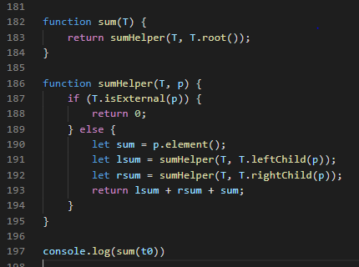
3. B. (a) Design a pseudo-code algorithm, findMax(T), that finds the maximum value stored in a binary tree.
4. Algorithm: findMaximum(T)
6. return findMaximumHelper(T, T.root())----------------------------O(1)
7. Algorithm: findMaximumHelper(T,p)
8. if T.isExternal(p) then --------------------------------O(1)
9. return - $∞$-----------------------------------------------------------O(1)
10. else
11. leftMax $←$ findMaximumHelper(T, T.leftChild(p))---------------O(n)
    * + 1. rightMax $←$ findMaximumHelper(T, T.rightChild(p))------------O(n)
12. return max(leftMax, rightMax, p.element()) -----------------------O(1)
13. so the running time is ---------**O(n)**

(b) Based on the Tree.js implementation of the binary tree, implement in JavaScript the function, findMax(T), that finds the maximum in a tree.

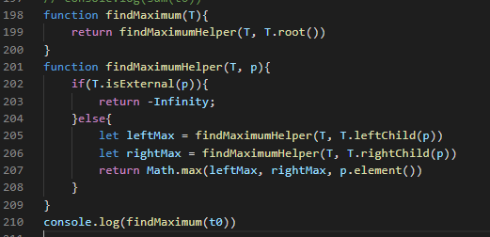

C. (a) Based on the EulerTour template class provided in Tree.js, implement a function sum that sums the elements in a binary tree. This is done by creating a subclass of EulerTour that overrides one or more hook methods in the superclass.

(b) Based on the EulerTour, implement a function the finds the maximum value in the tree.